Djibouti

## Political Stability Estimate Data

The data set shows the political stability estimate of the country each year.

## # A tibble: 19 x 5  
## country iso3c date stability stabilityCategory4   
## <chr> <chr> <dbl> <dbl> <chr>   
## 1 Djibouti DJI 1996 -0.339 moderately unstable  
## 2 Djibouti DJI 1998 -0.963 moderately unstable  
## 3 Djibouti DJI 2000 -0.242 moderately unstable  
## 4 Djibouti DJI 2002 -0.313 moderately unstable  
## 5 Djibouti DJI 2003 -0.913 moderately unstable  
## 6 Djibouti DJI 2004 -0.345 moderately unstable  
## 7 Djibouti DJI 2005 -0.813 moderately unstable  
## 8 Djibouti DJI 2006 -0.260 moderately unstable  
## 9 Djibouti DJI 2007 -0.122 moderately unstable  
## 10 Djibouti DJI 2008 0.270 moderately stable   
## 11 Djibouti DJI 2009 0.494 moderately stable   
## 12 Djibouti DJI 2010 0.253 moderately stable   
## 13 Djibouti DJI 2011 0.178 moderately stable   
## 14 Djibouti DJI 2012 0.161 moderately stable   
## 15 Djibouti DJI 2013 -0.102 moderately unstable  
## 16 Djibouti DJI 2014 -0.770 moderately unstable  
## 17 Djibouti DJI 2015 -0.444 moderately unstable  
## 18 Djibouti DJI 2016 -0.626 moderately unstable  
## 19 Djibouti DJI 2017 -0.708 moderately unstable

## Political Stability Estimate Plot

The plot shows the trends of stabilization and destabilization for the each country.

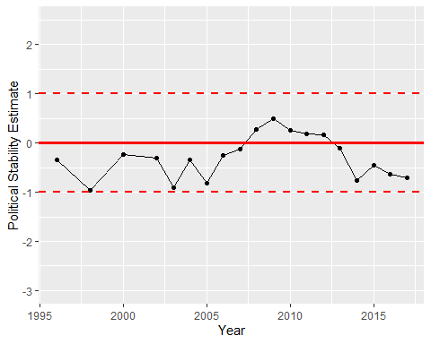

Political Stability Trend